Simplified hydroponics for urban agriculture – opportunities and challenges
S.H.Liyanarachchi¹ and M.D.J.S.Saparamadu²
¹EasyGrow (Guarantee)Ltd.,14A, Saparamadu Mw, Nugegoda.
Tel.0772673772; Email susilliyana@gmail.com
²Department of Chemistry, Open University, Nawala, Sri Lanka.
Tel: 0112881385, Email: mdsap@ou.ac.lk

Abstract: Simplified hydroponics system has been proved to be an appropriate technology for urban agriculture and to produce vegetables for household consumption which is most suited for communities with limited space. Efficient use of water, nutrient, time and labour are the distinct advantages of this technology which will suit busy professionals, women, elderly people and also people with disabilities. Results of the socio-economic assessment and market feasibility conducted involving community groups and institutions revealed that for the successful adoption of the technology and for scaling up it is important to make all three components of the simplified hydroponics system to be available on commercial basis.
INTRODUCTION
Urban agriculture practices include an array of livelihoods systems ranging from subsistence production and processing at the household level to commercialized agriculture (Ngumbi 2017), and globally, it is estimated that 800 million urban residents produce food for the urban markets providing 15-20 percent of the world food (Amar-Klemesu 2000). Urban agriculture can also contribute towards actual and potential urban challenges such as growing urban poverty and social exclusion, food insecurity and malnutrition in cities, enhance resilience of cities and reduce climate change/disaster risks, growing waste management problems and growing need for green space and recreational services for the urban population. (Sivaperuman 2018, Ranasinghe 2006)
Agricultural practices in urban areas require intensive use of space, water, nutrients and labour. Technological innovations can play a leading role in promoting urban agriculture as it can be adapted to a wide range of urban situations, and to the needs of diverse stakeholders.
SIMPLIFIED HYDROPONICS
Hydroponics, which comes from Greek words hudor- meaning water, and ponos- meaning working, refers to growing plants without soil. In hydroponics plants are provided with a constant supply of water and mineral nutrients. Hydroponics crop production systems are high in water use efficiency due to minimized run off, drainage and evaporation. The system also utilizes nutrients efficiently compared to soil grown systems thereby drastically reducing the pollution caused by fertilizer run off. There are hundreds of methods growing plants hydroponically, ranging from highly capital intensive fully automated computerized systems under greenhouse conditions to very simple units consist of a bucket or nursery pot filled with hydroponics growing medium and hand watered with a hydroponics nutrient.
Simplified hydroponics was developed in Colombia in the early 1980s and is a low-cost vegetable production system that utilizes modern day hydroponics principles adapted for areas with limited resources. Simplified hydroponics is practiced under natural climatic conditions, utilizes space efficiently and conserves nutrients and water by a simple mechanism (Bradely,2000). This technology is based on minimal inputs, requiring no green houses, pumps, commercial energy sources or expensive equipment. Simplified hydroponics gardens are built with recycled or discarded wooden or plastic containers, hand watered once a day with a commercial hydroponics nutrient.
The benefits that small-scale farmers could realize by adopting simplified hydroponics technologies are as follows.
- Minimal inputs requiring no pumps, external energy sources or expensive equipment
- Water required for simplified hydroponics is comparatively less and therefore, an alternative to cultivations carried out by farmers, particularly in the dry-zone areas of the country with seasonal rains. On average, simplified hydroponics save up to 60% of water per unit area compared to soil-based cultivation.
- Efficient and recycled use of water and fertilizer in hydroponics minimizes possible adverse effects on soil degradation and environment pollution due to fertilizer run off.
- Simplified hydroponics production system is well suited for women, people with disabilities and elderly people. Women can easily manage such a system with minimum labor and can be coupled easily with household chorus.

Simplified hydroponics system
The system consists of three components – grow boxes, inert medium and the nutrient solution.
- Grow Boxes
The type of grow boxes used were commercially available rigiform boxes of 15cmX 17cmX6cm size. Retail price of a box is Rs.300. There had been no major issues related to the durability and the utility of the rigiform box for growing plants. Rigiform boxes were covered with black polythene cover meant for preventing algal growth by restricting the diffusion of sunlight inside the box. Participants requested to have a choice of boxes of varying sizes having preference for 12 inches width. The unique feature of the box is the plastic flexible tubing which is 1.5 cm above the inner bottom of the box protruding from one side. When the water level reaches the level of the tubing, water drops come out indicating that water inside is sufficient for the day. The drops can be collected and add again on the next day preventing the environment pollution and also the waste of nutrients.

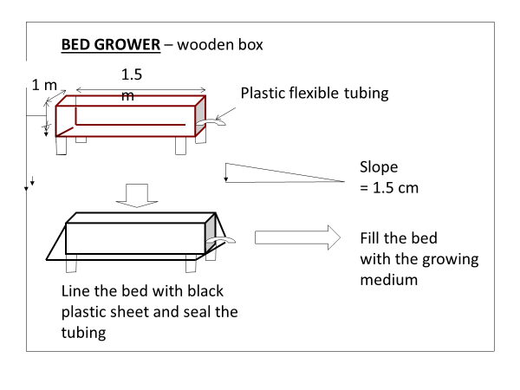
- Grow medium
The inert medium used for growing plants was a mixture of rice hull soaked and washed for five days and coarse river sand at 3:2 (v/v) ratio. The medium was to be prepared by the participants themselves according to the instructions given. Cost of river sand per box was about Rs.450 excluding the transport cost and the cost of rice hull was about Rs.20 per box. The amount of grow medium sufficient for one rigiform box is on average five numbers of four litre buckets.
- Nutrient Solution
We have developed a low- cost nutrient pack for this system and after conducting numerous field investigations, it has been patented nationally. Nutrient pack comprised of two components that are to be dissolved in 50 litres of water to prepare 50 litres of the nutrient solution. They are pack A and pack B (BG for growing period and BF for bloom & fruiting periods). Recommended dose of the nutrient solution was one yoghurt cup (100ml) of nutrient solution per plant per day at the grow stages and two yoghurt cups per plant after flowering. Ten nutrient packs (10 packs of A and 4 packs of BG and 6 packs of BF) were sufficient for a period of 5 months for 10 boxes (1/5 of a pack- 10 L/ box/month). The cost of one grow pack was Rs. 250/= and one bloom and fruiting pack was Rs. 280/=.

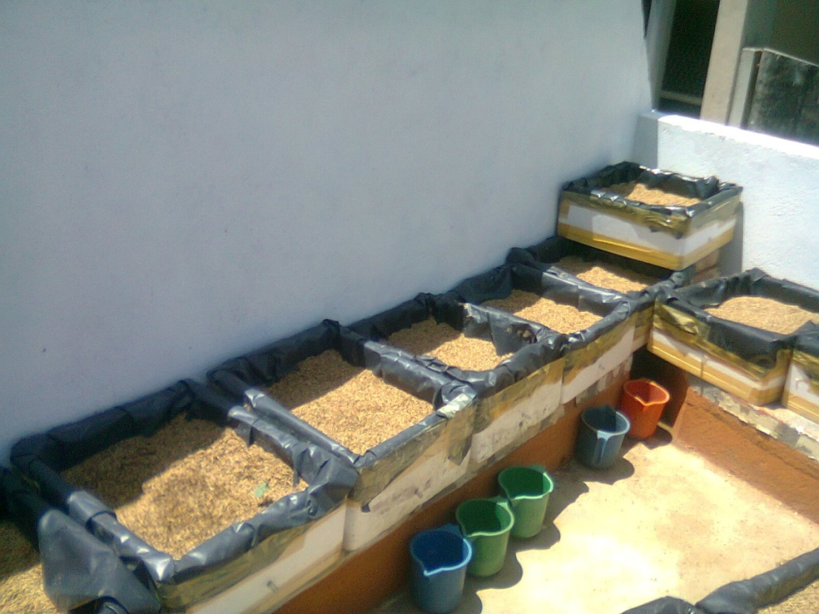
Fig. 1 Grow boxes and grow medium
Findings of field investigations
Numerous field investigations supported by National Science Foundation and non governmental organizations were conducted to investigate the feasibility of growing a vast array of vegetable species under this system. Field surveys were conducted in urban settings in participating with senior citizens living in housing schemes and interested in home gardening, schools and public institutions where the urban agriculture was practiced.
The system
The survey conducted asked participants to rate alternative materials that could potentially be used for grow boxes instead of rigiform. Of the four alternative materials presented; low cost wood, plastic, cement and clay pots, most respondents preferred material was plastic due primarily to easy handling. Main issue for wood was its low durability and for using cement boxes the limiting factor was the weight. However, cost is the main determining factor and Rs.200-400 has been identified as the most feasible price range for a box. Therefore, a major consideration in commercializing the system and its popularization is the cost of the grow box. Another recommendation is to have boxes having sufficient space to grow a single plant. This will also to make the cost of boxes more affordable.
Most of the respondents were of the view that the process of medium preparation is cumbersome and it should be commercially available. A major impediment in preparing the medium was difficulty in soaking for a period of 5 days. Those who were selected from housing schemes and the elderly participants mentioned that they find it difficult to access and transport the rice hull in addition to lack of a proper place for soaking and mixing. Those who preferred preparing the medium on their own were limited. In addition to commercially available rice hull and sand mixture, the need for commercially available packeted rice hull alone has also been mentioned to replenish decomposed rice hull after about 10-12 months of use.
Performance
Average yields obtained for different crops
crop | No. of plants/box | Yield/box  Kg. | Crop area Sq.ft.
Veraniya Chilies | 2 | 1.5 | 3.6
Cabbage | 2 | 3.0 | 3.6
Chilies | 2 | 1.6 | 3.6
Turnip | 2 | 2.0 | 3.6
Okra | 2 | 2.0 | 3.6
Capsicum | 2 | 1.0 | 3.6
Kochchi chilies | 2 | 1.0 | 3.6
Cauliflower | 2 | 0.5 | 3.6
Chinese Kale | 2 | 0.6 | 3.6
 | 2 | 1.2 | 3.6

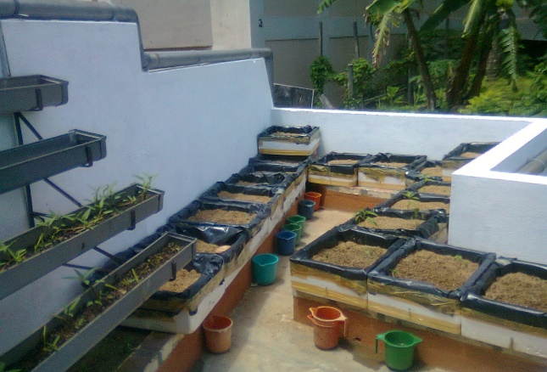
Fig.2. Simplified hydroponics garden lay out in a balcony

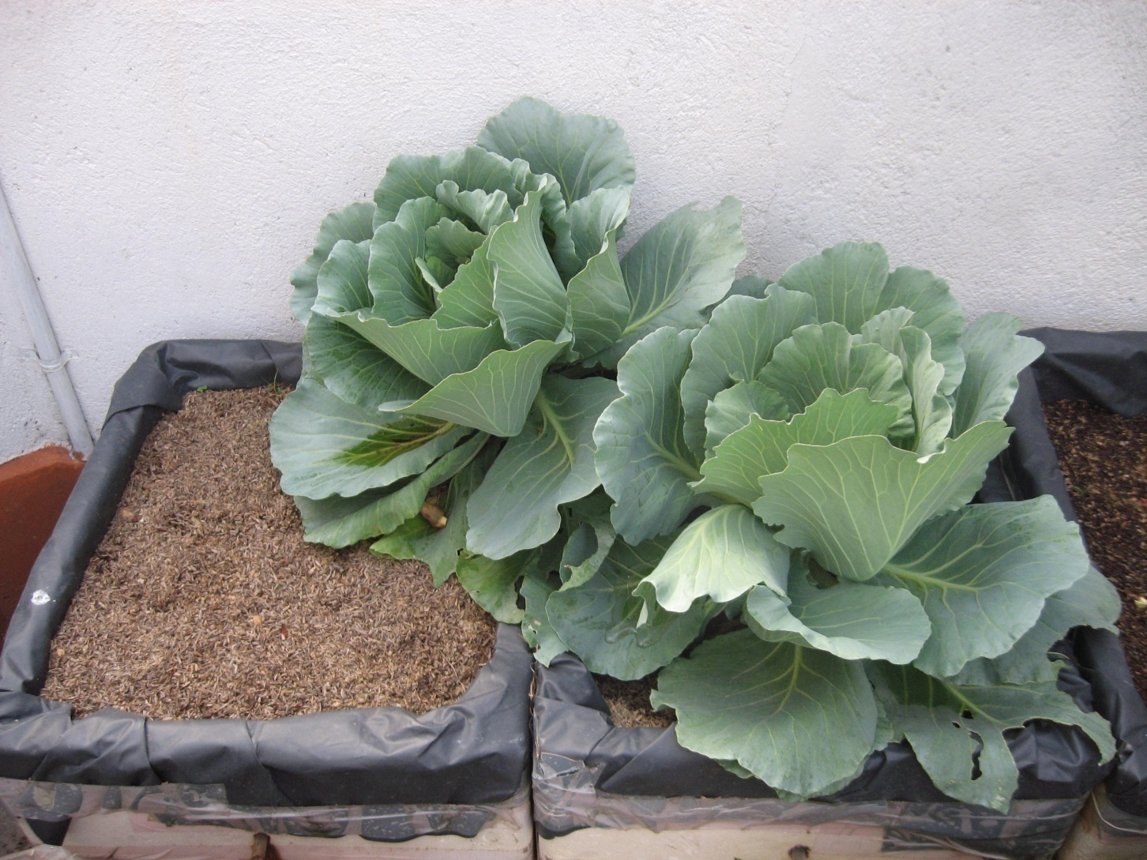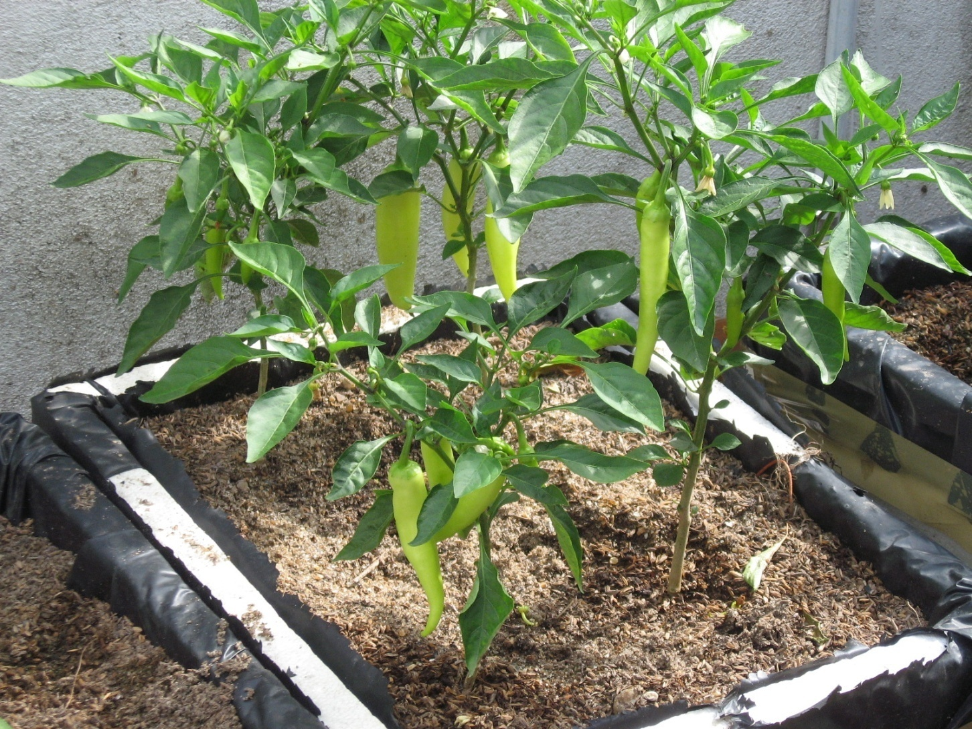
Fig. 3 cabbage and Chillies under simplified hydroponics

Comparison of average yield obtained with water and nutrient useage– Okra

Crop | No.of Beds | No.of Plants/Total | Total Yield Kg.
Okra | 4 | 8 | 3  (375g/ plant)
Total Nutrients Used - 96 Liters for 4- month Crop Cycle
Total amount of water used – 130 litres
Total cost of nutrients – Rs.500
Total cost for the boxes and medium (can be used for five years)- Rs. 3,200/5=Rs. 640
Cost per Kg. – Rs. 1140/3 = 380/

Cost estimate to supply the vegetable need for a family of four members for one months

Requirement | Vegetable requirement | No. of plants required | No. of beds | Total nutrient requirement.
250g/ day /vegetable | 5 varieties –  yield of 2/3 plant /variety/day | For 30 days- 20 plants/variety | 10/variety | 10 L x 10 boxes x 4 months  =400L= 8 packs/ variety
Total Nutrients Used for 4- month Crop Cycle – 8 packs x 5 = 40 packs
Total cost of nutrients – Rs.10,000
Total cost for the boxes and medium (can be used for five years)- Rs. 12,000
Total cost for the boxes and medium for four months - Rs. 800
Total expenditure for four months = 10,800
Total cost /day = Rs. 360 (for five vegetables for four persons)

SOCIO-ECONOMIC AND MARKET ASSESSMENT
This section consolidates the findings of the monitoring visits, individual interviews with growers and the focus group discussions that were held under different topics.
- Simplified hydroponics system is most appropriate for households with limited space. However, others who participated in the project having enough land for home gardening activities were of the opinion that due to less labour, less water, less time required for maintenance, absence of weed control, less soil borne diseases in simplified hydroponics system made it attractive to anyone who is interested in vegetable production for home consumption.
- It is recommended that all three components of the simplified hydroponics system needs to be commercialized, preferably along with high quality planting material so that not only those who are interested in home gardening, but also those who are inclined but not be fully committed could be attracted find all essential inputs to own an appropriate, affordable and accessible home garden which could be maintained without much hassle, even by those who are busy with other work. All of the respondents were of the view that once the simplified hydroponics garden is set up, the time required for daily maintenance which is primarily for applying the nutrients take no more than 15-20 minutes. In return the owner gets fresh vegetables free of pesticides and other harmful elements.
- It is important to maintain demonstration gardens in appropriate and relevant places for the public to view the operations, maintenance and the crop performance of simplified hydroponics systems.
- Success of simplified hydroponics gardens mainly depend on the interest, commitment and the attitude of the grower or the practitioner in home gardening. This may seem obvious. We found that targeting and working with those who are keen and interested in home gardening in initial stages of technology dissemination and adoption to make them convinced of the distinct advantages of the simplified hydroponics system would be an important first step towards popularization and facilitating wider adoption of this technology among the wider public. As we observed in the pilot study, those who are passionate about home gardening can act as catalysts to encourage those who get easily demotivated due to various problems one would face in crop growing in open environment. Those who are already accustomed to the vagaries of nature and the effect of numerous climate variables on crop production knows how to deal with those variables and find ways to overcome those obstacles through experience. This tacit knowledge and sharing of that is essential for the promotion of new technologies such as simplified hydroponics.
- Setting up of demonstration gardens in different agro-ecological zones would help generating interest on this technology and to see the advantages and also the limitations of the system. This will help communities to get a better understanding of the requirements and necessary adaptations to be made in respect to contextual specificities. This will also enable to identify specific crop varieties that are most suited to different climatic zones to plan the garden accordingly. Findings of the pilot study clearly showed the importance of holding an individual accountable system for setting up of and managing the demonstrations gardens. One of the main reasons for failures of simplified hydroponics gardens set up at institutions levels is that there were no one designated to manage the project and there were management issues in regard to the maintenance.
- Good quality planting material is a prerequisite for the success of hydroponics gardens. We found that seedlings are more appropriate compare to seeds. For simplified hydroponics gardens more mature seedlings are more suited.
- The most preferred material for grow boxes are those made out of plastics. It is important that plastic containers are resistant to UV radiation to increase the durability. Other than plastics, there are other alternatives such as appropriate containers made out of clay, cement and low-cost wood.
PROPOSED MARKETING STRATEGY
The following has been identified as the most appropriate marketing strategy for popularizing and scaling up the adoption of simplified hydroponics system homestead food production.
- To set up a company or a social enterprise managed by the developers of the nutrient solution to undertake the production of the simplified hydroponics nutrient pack ensuring the quality assurance of the product. The company will also undertake the setting up of demonstration gardens, technology training and dissemination and also get involved in research and development.
- Based on the findings of the field investigation and the survey and observations made all three components of the simplified hydroponics system needs to be available on commercial basis. This include; the grow boxes, grow medium and the nutrient solution.
- Grow medium will be manufactured by identified individual entrepreneurs from areas where the raw material for the production of medium, i.e. rice hull and river sand is available.
- Identify suitable suppliers/manufactures of grow boxes made out of different material as identified in the market survey to have a wider choice in relation to the material and different sizes to suit differential requirement of communities.
- Identify a private sector partner in the agro-enterprise field to market the all three components of the system having demonstration gardens. Selected private sector partner will use their existing market networks to distribute the product and for after sales services in consultation with other key stakeholders in the industry.
- To mobilize and train a selected group of simplified hydroponics growers from among the grassroots communities as promoters of the technology and to provide extension services on simplified hydroponics. This group can also be linked up with the marketing company as agents of nutrient distribution for a commission.
CONCLUSION
Simplified hydroponics system has been proved to be an appropriate technology that is suited to produce vegetables for household consumption which is most suited for communities with limited space. Efficient use of water, nutrient, time and labour without using any sophisticated equipment are the distinct advantages of this technology which will suit busy professionals, women, elderly people and also people with disabilities. Results of the socio-economic assessment and market feasibility conducted involving community groups and institutions revealed that for the successful adoption of the technology and for scaling up it is important to make all three components of the simplified hydroponics system to be available on commercial basis.
REFERENCES
Amar-Klemesu Margaret (2000) Urban agriculture and food security. www.ruaf.org/sites/default/files/theme4.
Bradely P and Marulanda C (2000) Home hydroponics gardens. Institute of for Simplified Hydroponics, P.O.Box 151, Corvallis, Oregon 97339, USA.
Ngumbu Esther (2017) Growing urban agriculture. Stanford Social Innovation Review 23, Oct.
Ranasinghe T (2006) Approaching with family business gardens: A new dimension of urban agricultural extension in Colombo, Sri Lanka. (www.cityfarmer.org/colombo html)
Sivaperuman C. ed. (2018) Biodiversity and climate change adaptation in tropical islands. Elsevier Inc. ISBN 978-0-12-813064-3
Van Veenhusen R. (2013) Urban agriculture in building resilient cities. ICLEI conference, Bonn, RUAF Foundation.

It is reported that about 290,000 families were affected by the drought annually during the period 1987-1997. The government of Sri Lanka has spent during this period nearly Rs.125 million for drought relief measures. The severe drought that prevailed in the country in 1995/96 has resulted in the drop of paddy production by 27%.

